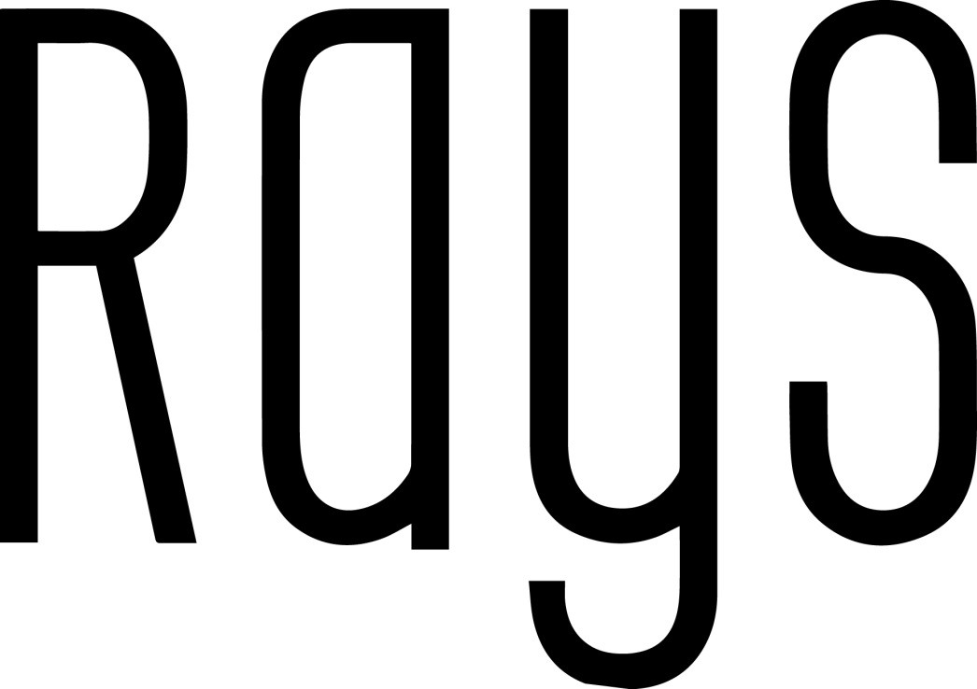

Dinner Menu
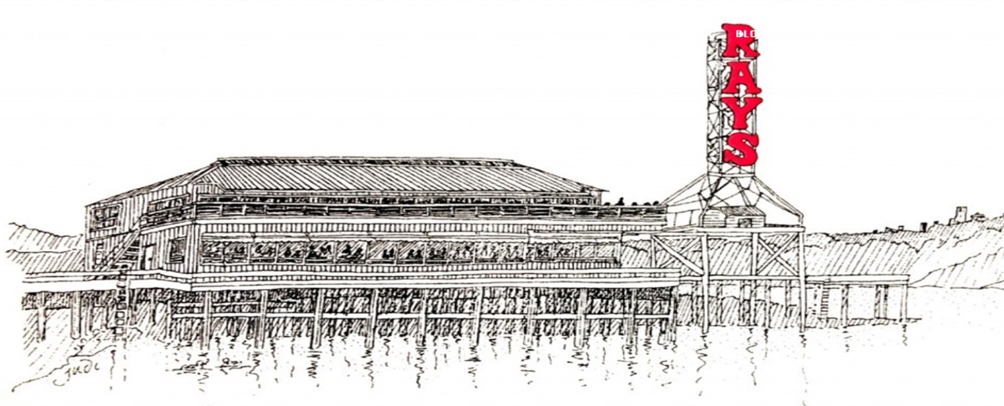
Spring - Summer 2026

Legend
V – Vegetarian | DF – Dairy Free | GF – Gluten Free | VGN – Vegan

A 20% service charge and 4% administrative fee will be added to all food and beverage. 100% of the 20% service charge is paid out to our culinary and wait-staff. WA State Sales Tax and service charge are subject to change without notice.
Passed or Stationed Appetizers – Minimum order of 2 dozen per item, all items are priced per dozen

SEAFOOD
Ray’s Cold Smoked Salmon* – rye bread crostini, dill cream cheese $61
Ray’s Smoked Wild Pacific Salmon Bites* – brandy-peach sauce DF/GF $59
Ray’s Smoked Sea Scallops – spicy miso-soy sauce DF $57
Tuna Poke* – wonton cracker, ponzu, sesame seed, cilantro, scallions DF $56
Del Pacifico Day-Boat Grilled Prawns – harissa sauce DF/GF $60
Dungeness Crab Cakes – ancho aïoli $120
Albacore Bites* – lightly seared albacore tuna, aleppo pepper-salt, ponzu DF/GF $59
Crab Dip Stuffed Sweet Peppers – Dungeness crab meat- artichoke dip GF $80
Ray’s Smoked Black Cod Bites – miso-ginger glaze DF $60
Smoked Salmon Devilled Eggs – sour cream, herbs, ikura, smoked sea salt GF $52

MEAT
Ray’s Smoked Pork Belly Skewer – apple cider gastrique, poppy seeds DF/GF $53
Beef and Pork Meatballs – marinara sauce, basil, Grana Padano $49
Beef Crostini* – charred shallot cream cheese, chimichurri sauce $58
Pastry Wrapped Uli’s Sausage – stone ground mustard sauce $52
Chicken Mole Skewers – cotija, cilantro $50
Coulotte Beef and Mushroom Skewer – kalbi marinated beef, Korean BBQ sauce DF/GF $58
Chicken Tikka Masala Skewer – spiced yogurt marinated chicken, tikka masala sauce GF $50
Brie Cheese & Prosciutto Monté – brioche bread, brie cheese, bourbon-blueberry butter $49

VEGETARIAN
Grilled Seasonal Fruit Crostini – mascarpone, toasted almonds, sage-honey $41
Tomato Crudo Cucumber Cups – bell pepper, tomato, caper, basil, lemon oil DF/GF $40
Caprese Salad Skewer – fresh mozzarella, basil pesto, tomato, basil, balsamic glaze GF $42
Zucchini and Feta Cheese Fritters – tzatziki $43
Mixed Vegetable Tempura – ginger-soy dipping sauce DF $40
Sweet Peppers – house-made guacamole, tortilla strips DF $44
French Onion Tartlet – caramelized onions, gruyere cheese, breadcrumbs, thyme $48
Cannellini Bean Crostini –crostini, sundried tomato tapenade DF $40
Sweet Cantaloupe Gazpacho Shooters – chives DF/GF $40
House made Falafel – lemon tahini dressing DF $44
Petite Grilled Cheese ^{V} – brioche, cheese curds, seasonal jam $41

Tray passed items are subject to an additional labor fee of $25 per server per hour. Final cost to reflect number of servers needed.

BUFFET APPETIZERS
Prices are per person

SALADS
Farm Lettuces and Greens Salad ^{GF, V}
seasonal fruit, cucumbers, Marcona almonds, white cheddar cheese, apple cider vinaigrette
$15 per person

Caesar Salad
garlic croutons, parmesan cheese ribbons, Caesar dressing, lemon
$15 per person

Butter Lettuce Salad ^{GF, V}
butter lettuce, cucumbers, breakfast radish, pears, Pecorino cheese, toasted pinenuts, white balsamic vinaigrette
$15 per person

Artisanal Panzanella Bread Salad ^{DF, V}
romaine lettuce, tomatoes, Kalamata olives, red onions, basil, capers, grilled bread, stone ground mustard vinaigrette
$15 per person

Fusilli Salad ^{V}
cherry tomatoes, red onion, Castelvetrano olives, basil, oregano, fresh mozzarella cheese, sundried tomatoes, paprika vinaigrette
$15 per person

Barley Salad ^{V}
Sundried tomatoes, barley, spinach, Roma tomatoes, celery, peas, feta cheese, tomato vinaigrette
$15 per person

Orzo Salad ^{V}
orzo pasta, spinach, zucchini, piquillo pepper, Kalamata olives, Manchego cheese, red wine vinaigrette
$15 per person

SEAFOOD

Ray’s Grilled Wild Pacific Northwest Salmon Sides* ^{GF}
lemon beurre blanc
$17 per 2-ounce portion

Ray’s Chilled Seafood Display* ^{DF}
cold smoked salmon, smoked scallops, chilled white prawns, ahi poke, Alaskan tanner crab, cocktail sauce, ponzu, lemon aïoli, Louis dressing, croccantini
$48 per portion, minimum 20 portion

Seafood Ragout ^{DF}
PNW Manila clams & mussels, Del Pacifico day-boat prawns, calamari rings, fennel-tomato ragout sauce, grilled garlic baguette
$30 per half pound portion

Sesame Encrusted Ahi Tuna* ^{GF/DF}
Asian-style coleslaw, ginger-soy dressing
$16 per 2-ounce portion

Seafood Paella ^{GF/DF}
PNW Manila clams & mussels, Del Pacifico day-boat prawns, Uli’s chorizo, arborio rice
$29 per half pound portion

Pacific Northwest Mussels ^{DF}
Thai style red curry coconut broth, grilled baguette
$21 per half pound portion

Local Oysters on the Half Shell* (seasonally available) ^{GF/DF}
red wine mignonette, Ray’s cocktail sauce
$ Market Price per dozen minimum 4 dozen

Steamed PNW Manila Clams
Uli’s chorizo, garlic, sherry wine, herbs, butter, grilled baguette
$21 per half pound portion

Chilled Del Pacifico Day-Boat Prawns ^{GF/DF}
Ray’s cocktail sauce, lemon
$61 per dozen

LANDFOOD
Roasted Chicken Breast ^{DF/GF}
spice rubbed roasted chicken breast, grilled onions, bacon lardons, red sauce
$16 per 2-ounce portion

Coconut Crusted Chicken Breast ^{GF}
wasabi-garlic cream, braised greens
$16 per 2-ounce portion

Roasted Petite Beef Tenderloin* ^{DF/GF} grilled seasonal vegetables, demi-glace
$22 per 2-ounce portion

Tuscan Antipasto Charcuterie ^{DF}
sliced salami, red wine cooked mushrooms, Castelvetrano olives, Kalamata olives, marinated artichoke hearts, Mama Lil’s pickled peppers, Grand Central Bakery breads, rosemary croccantini, house pickled vegetables
$28 per portion, minimum 20 portions

Caprese Flat Bread
Basil pesto, mozzarella, tomatoes
$36 each (Serves 8)

Chorizo Flat Bread
Uli’s chorizo, marinara, Manchego cheese, red onion
$41 (Serves 8)

Roast Prime Rib of Beef* ^{GF}
demi-glace, horseradish cream
$42 per 4-ounce portion, minimum 20 portions

Herb Rolled Leg of Lamb* ^{GF/DF}
Dijon mustard pan sauce, lemon-parsley gremolata
$42 per 4-ounce portion, minimum 20 portions

Grand Central Bakery Focaccia and Butter
$3.00 per guest

CARVING STATIONS
Carving stations for roast prime rib of beef, garlic and herb rolled leg of lamb are available by request.
$100 service charge
VEGETARIAN

Market Cheese Board ^{V}
Chef’s selection of imported and domestic artisan cheeses, Grand Central Bakery breads, rosemary croccantini, dried fruit, mixed nuts
$23 per portion, minimum 20 portions

Crostini Bar ^{V}
hummus, roasted red pepper dip, creamy feta with olives, pita bread, crostini
$14 per portion, minimum 20 portions

Chilled Herb Roasted Seasonal Vegetables and Potatoes ^{V/ GF}
green goddess dressing
$13 per portion, minimum 20 portions

Fresh Vegetable Crudités ^{V/GF}
blue cheese dressing
$13 per portion, minimum 20 portions

Freshly Sliced Seasonal Fruit ^{V/GF}
$13 per portion, minimum 20 portions

PLATED DINNERS
Served with Grand Central Bakery bread, Caffé Vita Coffee, and Mighty Leaf Tea
*It is required of you to provide meal cards for a plated meal

SOUPS
Please select one soup for your group

White Bean ^{VGN/DF/GF}
lacinato kale, vegan basil pesto
$12

Roasted Tomato ^{V}
creamy tomato soup, basil
$12

Vanilla Scented Corn ^{V/GF}
charred sweet corn, blistered tomato
$12

Ray’s Clam Chowder
New England style with clams and house smoked bacon
$15

Smoked Salmon Chowder
Ray’s smoked salmon, New England style chowder
$16

SALADS
Please select one for your group

Butter Lettuce Salad ^{V /GF}
butter lettuce, cucumbers, breakfast radish, pears, Pecorino cheese, toasted pinenuts, white balsamic vinaigrette
$15

Grilled Caesar Salad ^{V}
little gem romaine lettuce, garlic croutons, shaved parmesan cheese, Caesar dressing, lemon wedge
$15

Spinach Salad ^{V /GF} cherry tomatoes, radishes, feta cheese, toasted pinenuts, citrus vinaigrette $15

Arugula Salad ^{V /GF}
Shaved fennel, chevre, watermelon radish, orange segments, pistachios, grapefruit vinaigrette
$15

DINNER ENTREES
Select 3 total dinner entrées for your group to choose from
Dinner counts are due 10 business days prior to your event. Clients must provide meal cards.

SEAFOOD

Grilled Wild Pacific Northwest Salmon* ^{GF}
roasted vegetables, whipped Yukon Gold potatoes, lemon beurre blanc sauce
Coho Salmon $47
King Salmon $58

Pan Seared Wild Pacific Northwest Alaskan Halibut ^{GF/DF}
corn puree, sweet corn succotash, blistered cherry tomatoes, scallion
$57

Pan Seared Wild Pacific Northwest Rockfish
parmesan fregola sarda, seasonal vegetables, caper-butter sauce
$42

Wild Pacific Northwest Sablefish Sake Kasu ^{GF/DF}
honey-soy, scallion oil, jasmine rice, garlic-ginger sautéed bok choy
$56

Wild Pacific Northwest Smoked Sablefish ^{DF}
wild rice, garlic-ginger sautéed bok choy, pickled cucumber, scallions, spicy-miso soy sauce
$56

Diver Seared Scallops ^{GF}
Saffron-cauliflower puree, baby summer vegetables, yuzu chimichurri
$55

RED MEAT

Grilled Marinated Coulotte Steak* ^{GF}
rustic bleu cheese fingerling mashed potatoes, seasonal roasted vegetable, sweet peppers, demi-glace
$55

Grilled Beef Tenderloin* ^{GF}
herb rubbed grilled tenderloin, creamy Yukon Gold potatoes, asparagus, demi-glace
$65

Pan-Seared Ribeye Steak* ^{GF}
cast iron seared, roasted garlic whipped potatoes, grilled vegetables, demi-glace
$67
Braised Beef Short Ribs ^{GF}
smashed fingerling potatoes, roasted vegetables, horseradish gremolata, braising sauce
$68, minimum 8 portions

POULTRY

Seared Duck Breast* ^{GF}
seared five-spice duck breast, rhubarb compote, braised red cabbage, wild rice
$52

Grilled Jidori Chicken Breast ^{GF/DF}
paprika marinated Jidori chicken, duck fat cooked red potatoes, broccolini, smoked tomato sauce
$42

Pan Seared Jidori Chicken Breast ^{GF}
Fingerling potatoes, roasted baby carrots, chicken jus, herbs
$42

VEGETARIAN

Edamame Soba Noodles ^{V}
mushroom stock, edamame, carrots, snap peas, mushrooms, scallions, cilantro
$37

Lemon Ricotta Agnolotti ^{V}
Seared asparagus, sauteed mushrooms, green pea puree
$40

Vegetable Coconut Curry ^{VGN/GF/DF}
Ginger-lemongrass coconut milk curry, green beans, corn, red bell peppers, fresh herbs, scallion oil, white rice
$36

DUET ENTREES

Grilled Wild Pacific Northwest Coho Salmon and Petite Beef Tenderloin* ^{GF}
whipped Yukon Gold potatoes, seasonal vegetables, lemon beurre blanc,
red wine-peppercorn sauce
$68

Petite Beef Tenderloin and Dungeness Crab Cake Oscar
herbed roasted fingerling potatoes, seasonal vegetables, hollandaise sauce
$74

DINNER BUFFETS
Buffets include Grand Central Bakery breads, butter, Caffé Vita coffee, and Mighty Leaf tea

CLASSIC NORTHWEST - $76 per guest

Butter Lettuce Salad ^{V/GF}
butter lettuce, cucumbers, breakfast radish, pears, Pecorino cheese, toasted pinenuts, white balsamic vinaigrette

Orzo Salad ^{V}
orzo pasta, spinach, zucchini, piquillo pepper, Kalamata olives, Manchego cheese, red wine vinaigrette

Seared Wild Pacific Northwest Rockfish Piccata
white wine-lemon-caper sauce

Coconut Crusted Chicken Breast
Wasabi-garlic cream, braised greens

Roasted Garlic Mashed Potatoes and Seasonal Vegetables ^{GF}

Grand Central Bakery Focaccia and Butter

BALLARD - $82 per guest

Caesar Salad
Garlic croutons, parmesan cheese ribbons, Caesar dressing, lemon

Barley Salad ^{V}
Sundried tomatoes, barley, spinach, Roma tomatoes, celery, peas, feta cheese, tomato vinaigrette

Grilled Wild Pacific Northwest Salmon* ^{GF}
lemon butter sauce

Grilled Marinated Flank Steak* ^{GF/DF}
glazed cipollini onions, demi-glace

Roasted Garlic Mashed Potatoes and Seasonal Market Vegetables ^{GF}

Grand Central Bakery Focaccia and Butter

EMERALD CITY - $88 per guest

Farm Lettuces and Greens Salad ^{GF}
seasonal fruit, cucumbers, Marcona almonds, white cheddar cheese, apple cider vinaigrette

Fusilli Salad
cherry tomatoes, red onion, Castelvetrano olives, basil, oregano, fresh mozzarella cheese, sundried tomatoes, paprika vinaigrette

Grilled Wild Pacific Northwest King Salmon Sides* ^{GF}
lemon beurre blanc

Roasted Petite Tenderloin* ^{GF/DF}
horseradish cream (contains dairy), demi-glace

Whipped Yukon Gold Potatoes and Seasonal Market Vegetables ^{GF}

Grand Central Bakery Focaccia and Butter

SNACKS

Pedro’s Chips and Guac
house-made guacamole, corn tortilla chips, salsa fresca ^{DF}
$14 per portion, minimum 20 portions

Mixed Pickled Vegetables ^{GF}
chilled seasonal vegetables, tzatziki dipping sauce
$12 per portion, minimum 20 portions
Smoked Salmon Deviled Eggs* ^{GF}
Ray’s smoked salmon deviled eggs, sour cream, fresh herbs, Ikura, smoked sea salt
$52 per dozens of halves, minimum 2 dozen halves

House-Made Potato Chips
crème fraîche, chives
$12 per portion, minimum 20 portions
Add Ikura* to crème fraîche $10 per portion

Spiced Almonds and Cashews ^{V/GF}
$8 per portion, minimum 20 portions

SLIDER BAR (minimum 1 dozen)
Grilled Beef Sliders
poblano aïoli, white cheddar cheese, lettuce, tomato
$7 each

Seared PNW Salmon Sliders ^{DF}
lemon aïoli, pickled cucumber and onion, arugula
$7 each

Slow Roasted BBQ Pulled Pork
homemade smoked apple BBQ, white cheddar cheese, pickled red onions, jalapeños
$7 each

Equipment Rentals and Additional Charges
Prices for events in our Northwest Room only

Wireless Internet Complimentary

Projection Screen (5.5x5.5) Complimentary

LCD Projector $200

Handheld Wireless Microphone Complimentary

Lectern Complimentary

Easels Complimentary

Deck/Patio Heaters Complimentary

Dance Floor $150

Outside Dessert Fee** $2 per guest

Additional Tenting *Varies

*For additional audio-visual equipment or deck tenting, please contact your sales manager for a quote

** Any dessert served by our team must be produced in a professional kitchen/bakery.

